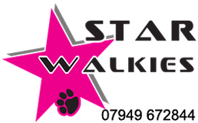
Star Walkies
White Briar Cottage
Duns Road
Grantshouse
Duns
TD11 3RW

starwalkies1970@gmail.com
0794 967 2844

OFF-LEAD WALKING CONSENT FORM
I, the below named client, give the Star Walkies permission to walk my dog off its lead during any walk undertaken during my absence.
I understand the potential consequences that could occur to my dog or to other dogs if walking my dog off the lead while in the care of the Star Walkies. I agree to release The Star Walkies from all liability including its members, agents, managers, and employees should my dog become lost, injured or otherwise harmed which may result in my dog being walked off the lead.
Star Walkies agrees to exercise all reasonable and due care to prevent injury or death to my dog off the lead - however, in the event of injury/death, except those caused by reckless acts on the part of Star Walkies, Star Walkies will not be held liable for such injury/death of my dog as a result of off-lead walking.
I freely and voluntarily enter into this contract of permission with Star Walkies and fully understand the above conditions.
FULL NAME:
SIGNATURE: DATE:

SERVICE PROVIDER:
SIGNATURE: DATE:

